**Lesson 8: Retrieving Data from Multiple Tables**

* The data that we need for a report could be located in more than one table. In order to select the data from the tables, join the tables in a query.
* Joining tables enables us to select data from multiple tables as if the data were contained in one table.
* Joins do not alter the original tables.

**The UNION Operator(UNION and UNION All)**

* The UNION operator is used to combine the result-set of two or more SELECT statements.
* Each SELECT statement within UNION must have the same number of columns.
* The columns must also have similar data types
* The columns in each SELECT statement must also be in the same order.
* The UNION operator selects only distinct values by default.
* To allow duplicate values, use UNION ALL

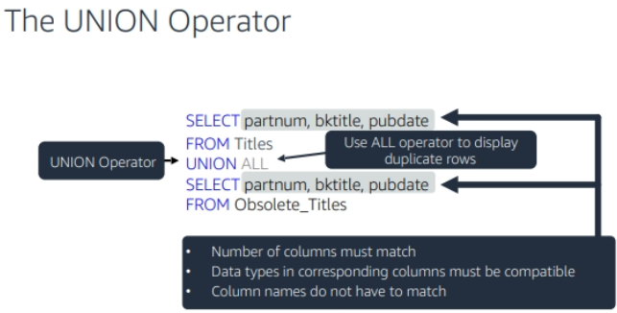

**UNION** operator with **WHERE** and **ORDER BY**

SELECT partnum, bktitle, pubdate FROM Titles

WHERE pubdate between "2012-01-01" AND "2017-12-30"

UNION ALL

SELECT partnum, bktitle, pubdate FROM Obsolete_Titles

WHERE pubdate between "2012-01-01" AND "2017-12-30"

ORDER BY partnum;

**Entity Relationships**

* An **Entity Relationship** shows entities (tables) in a database and relationships between tables within that database.
* An **Entity** is an object in the real world with an independent existence that can be differentiated from other objects. An entity might be
  + An object with physical existence (e.g., Student, Instructor, Car, Employee, Customer)
  + An object with conceptual existence (e.g., a course, a job, a position)
* **Attributes** are the data we want to collect for an **Entity**.
  + E.g For Titles entity(table) above we have attributes partnum, bktitle and pubdate.
* **Relationships**, defined as the associations or interactions between **Entities(Tables)**

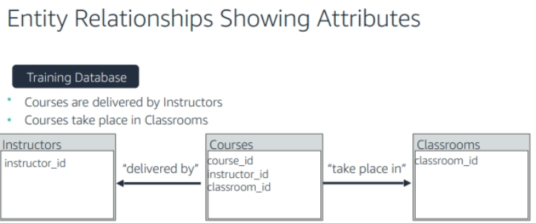





* The related tables of a database are linked through the use of **foreign** and **primary** **keys** or what are often referred to as common columns.

Basically databases has three main keys:-

**Candidate Key**

* A candidate key is a simple or composite key that is unique and minimal.

E.g- **instructor_id** or **lastName** combined with **firstName** as one key.

**Primary Key**

* The primary key is a candidate key that is selected by the database designer to uniquely identify a record in a table (relation).
* It must uniquely identify tuples in a table and cannot be **Null**.

E.g- **instructor_id**, or **course_id** or **classroom_id**

**Foreign Key**

* Foreign key is an attribute in a table that references the primary key in another table OR it can be **Null**.
* Both foreign and primary keys must be of the same data type.

E.g- In the **Courses** table **course_id** is a **primary key** and **instructor_id** and **classroom_id** are **foreign keys**.